T-Line Homework 2 (18 Points)
(jas, T-Line HW2.docx, 9/01/2022)

Use units and clearly label answers using 3 or 4 significant digits where appropriate. Show your work so that if necessary partial credit can be awarded.
- A 75 Ω transmission line is connected to a load consisting of a 47 pf capacitor.

- Calculate the reflection coefficient for the line when driven by a 10 MHz sinusoid. Express the phase angle of the reflection coefficient in units of degrees. (Hint: Your phase angle should range between -20˚ and -30˚). (4 Points.)
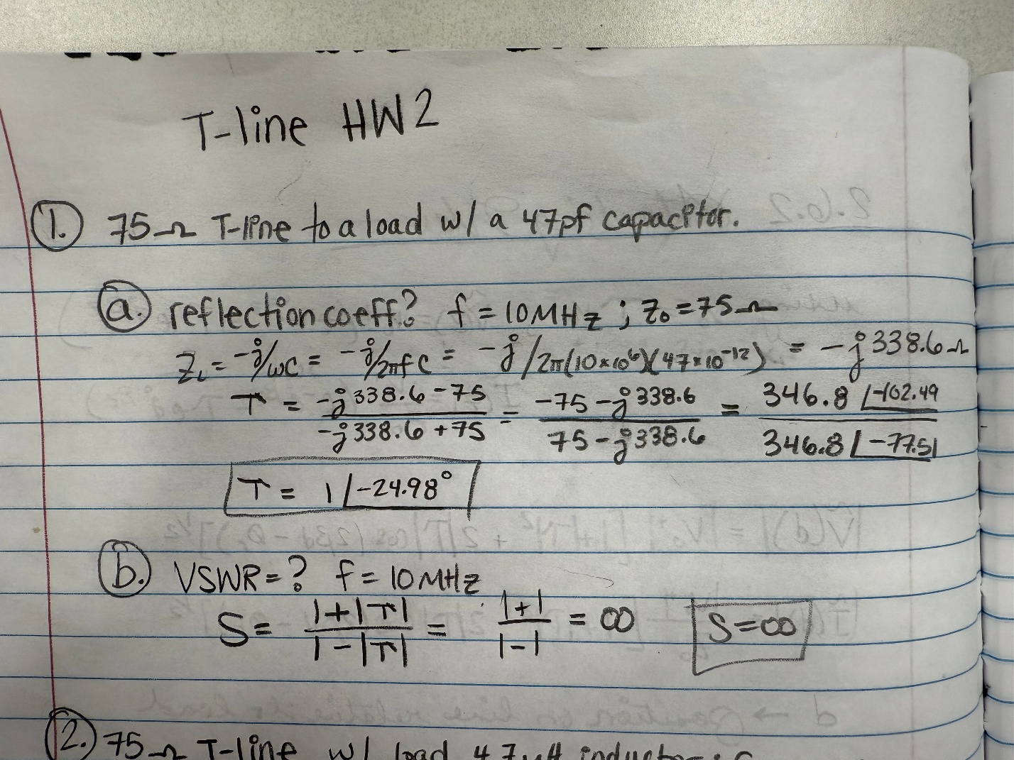

- Calculate the voltage standing wave ratio (VSWR) for the line when driven by a 10 MHz sinusoid. (Hint: Expect a large number for your answer) (2 points.)
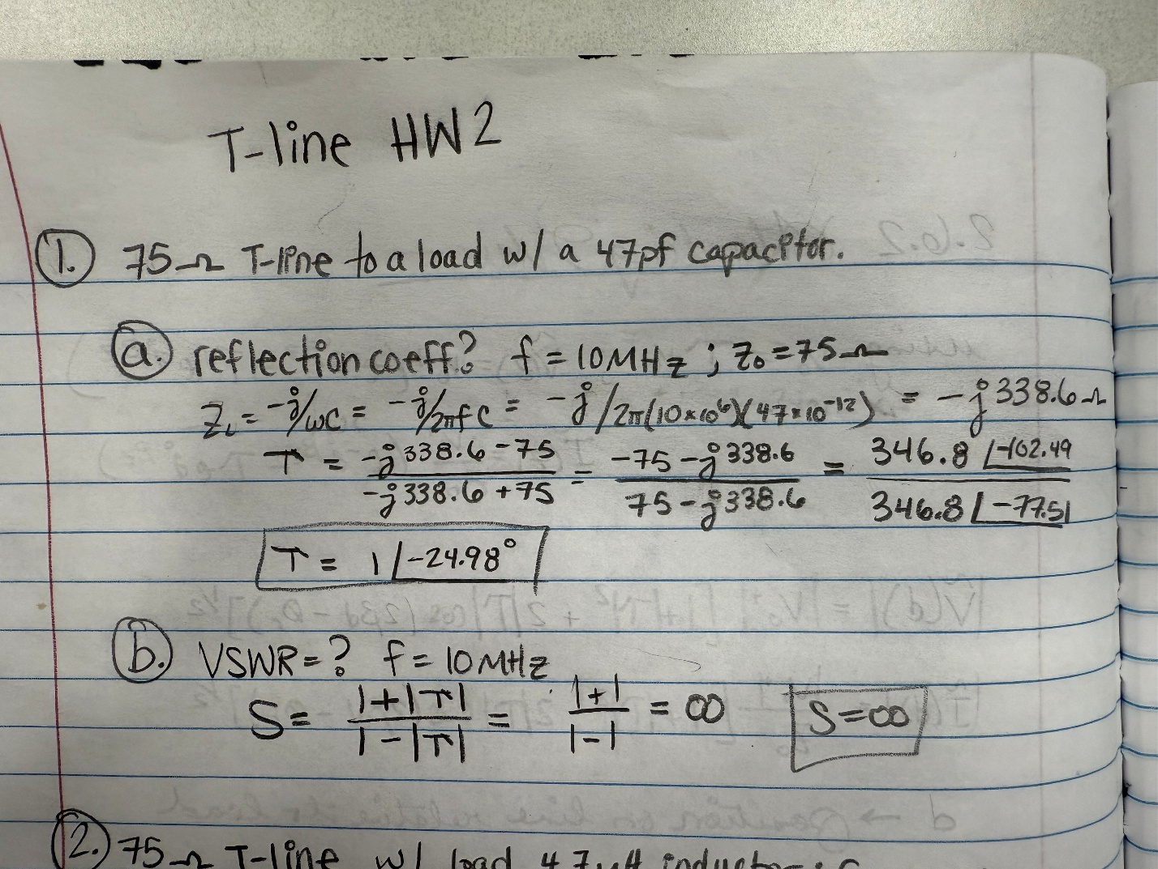

- A 75 Ω transmission line is connected to a load consisting of a 4.7 µH inductor.

- Calculate the reflection coefficient for the line when driven by a 10 MHz sinusoid. Express the phase angle of the reflection coefficient in units of degrees. (Hint: Your phase angle should range between 25˚ and 30˚). (4 Points.)
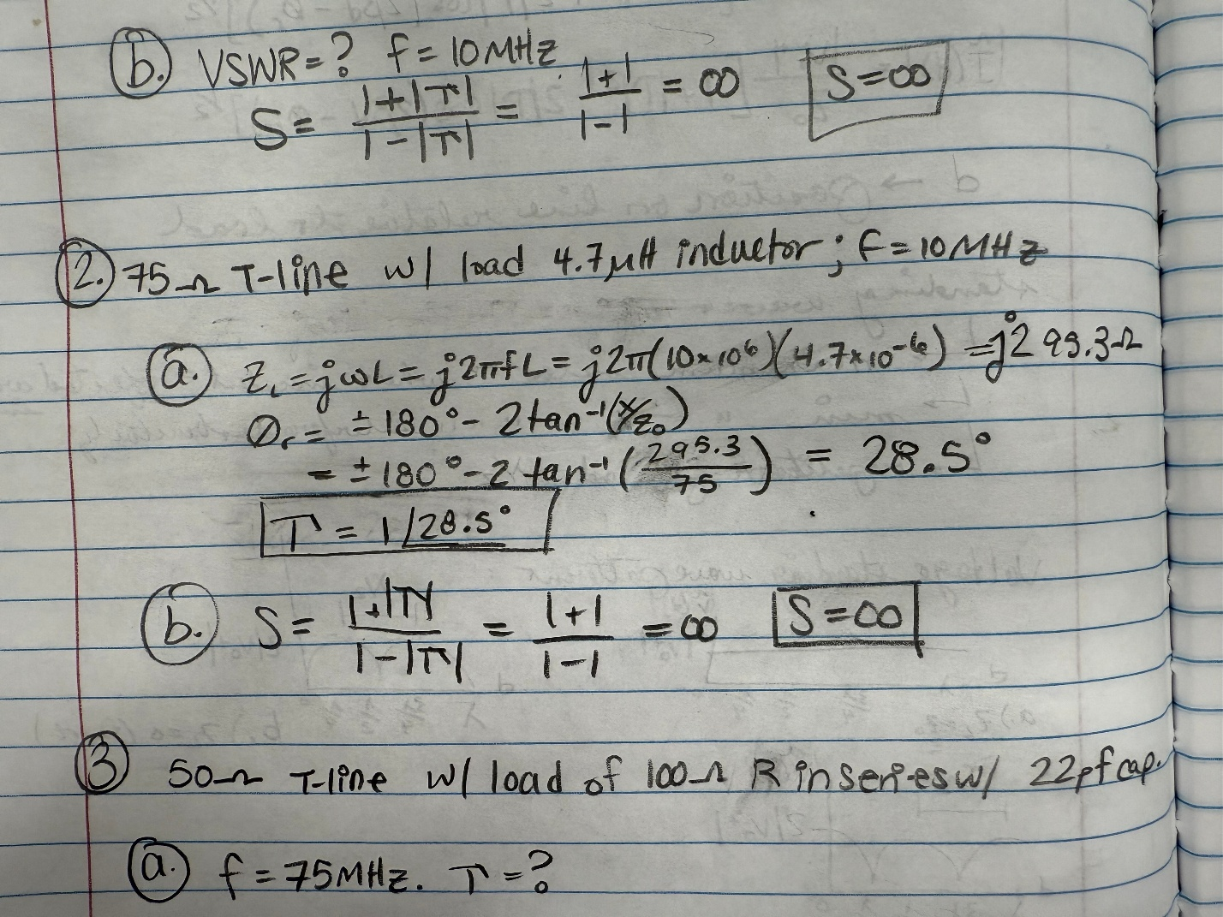

- Calculate the voltage standing wave ratio (VSWR) for the line when driven by a 10 MHz sinusoid. (Hint: Expect a large number for your answer) (2 points.)



- A 50 Ω transmission line is connected to a load consisting of a 100 Ω resistor in series with a 22 pf capacitor.

- Calculate the reflection coefficient for the line when driven by a 75 MHz sinusoid. Express the phase angle of the reflection coefficient in units of degrees. (Hint: Your phase angle should range between -25˚ and -35˚). (4 points.)
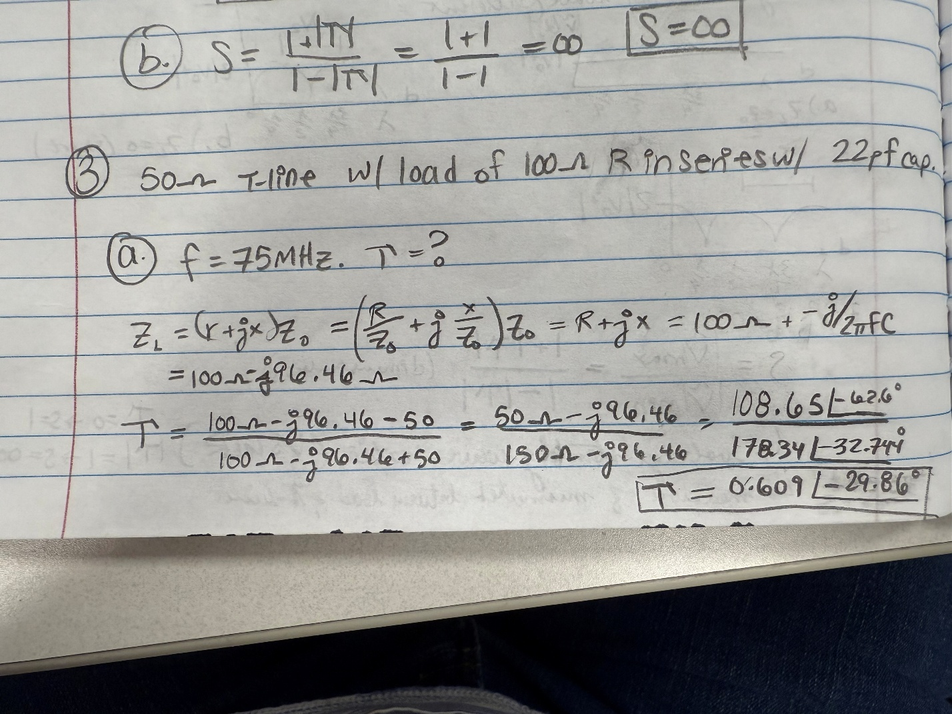

- Calculate the voltage standing wave ratio (VSWR) for the line when driven by a 75 MHz sinusoid. (Hint: Answer should be between 3 and 5) (2 points.)

